Xin Zhao
Professor David Klappholz
CS 561 WS
08/12/2021
Final Exam
1. Translate the following ER diagram into an equivalent minimal storage relational design. (Be sure to include all necessary keys and foreign key references.)

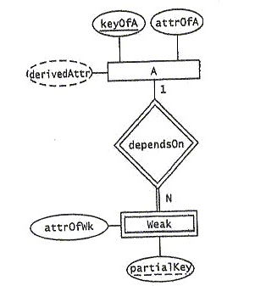Sol:
Minimal storage translation:
A
attrOfA | keyOfA

Weak
attrofWk | partialKey | keyOfA

- Translate the following ER diagram into an equivalent minimal storage relational design. (Be sure to include all necessary keys and foreign key references.)
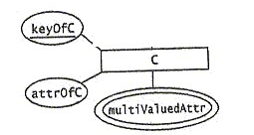
Sol:
Minimal storage translation:
C
attrOfC | keyOfC
C_multivaluedAttr
keyOfC | multivaluedAttr

- 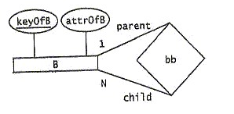Translate the following ER diagram into an equivalent minimal storage relational design. (Be sure to include all necessary keys and foreign key references.)
Sol:
Minimal storage translation:
B
attrOfB | keyOfB | keyOfB_parent

- 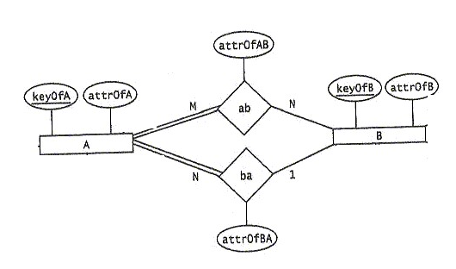Translate the following ER diagram into an equivalent minimal storage relational design. (Be sure to include all necessary keys and foreign key references.)
Sol:
Minimal storage translation:
A
attrOfA | keyOfA | attrOfBA

B
attrOfB | keyOfB

ab
keyOfA | keyOfB | attrOfAB

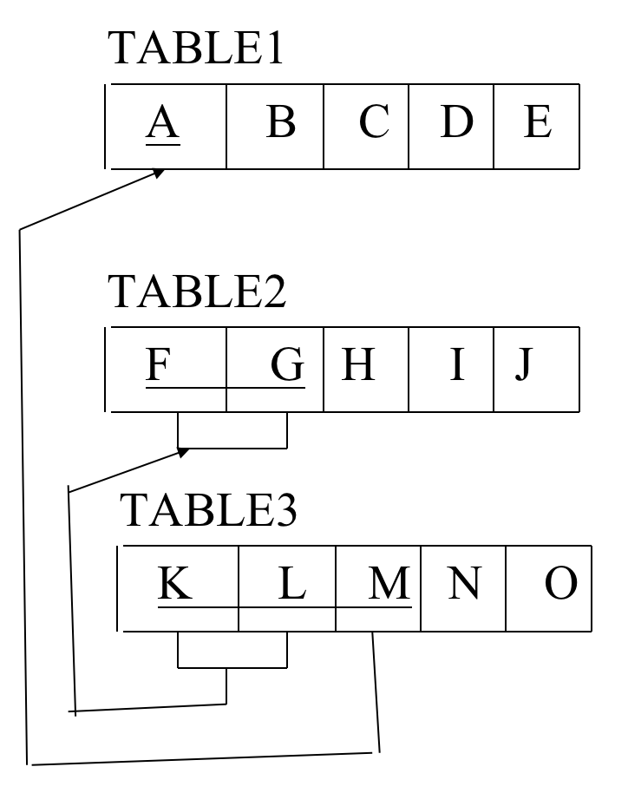
- Translate the following relational design into an equivalent ER diagram.
Sol:
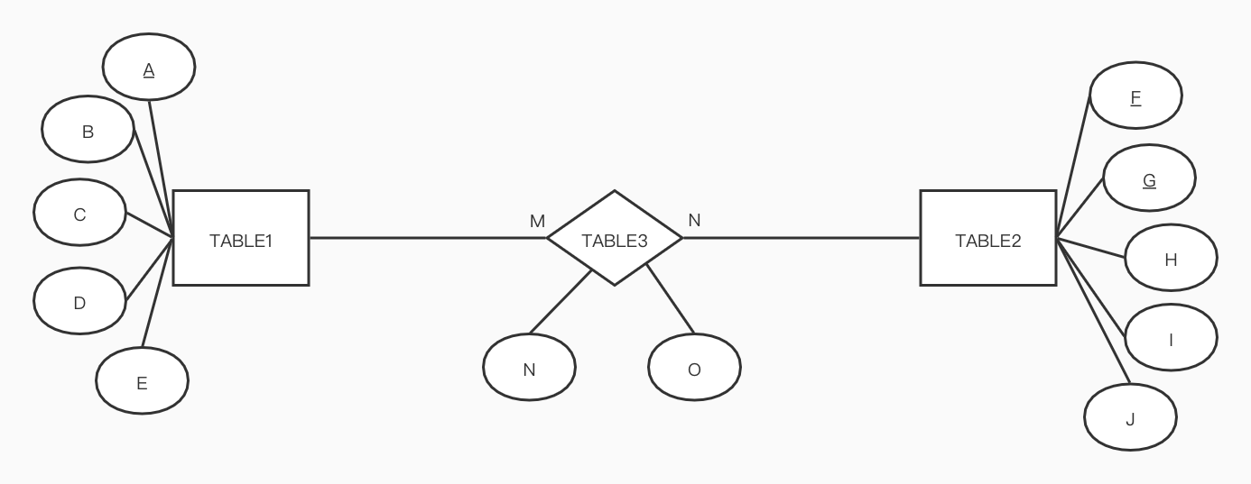

6. Consider the following table schema and functional dependencies:
- Table4(A, B, C, D, E, F, G)
- A->B
- GB->C
- GB->E
- GB->F
- C->D
- D->E

Find and remove all redundant left hand side attributes. Be sure to show all the details of how you arrived at your answer. (No credit otherwise)
Sol:
Step1: redundant left hand side attribute
- Is G redundant in GB->C?
F0 = {A->B, GB->C, GB->E, GB->F, C->D, D->E}
F1 = {A->B, B->C, GB->E, GB->F, C->D, D->E}
A^{+F0} = AB A^{+F1} = ABCDE
So the two sets of fd’s are not equivalent
- Is B redundant in GB->C?
F0 = {A->B, GB->C, GB->E, GB->F, C->D, D->E}
F2 = {A->B, G->C, GB->E, GB->F, C->D, D->E}
A^{+F0} = AB A^{+F2} = AB
G^{+F0}= G G^{+F2}= GCDE
So the two sets of fd’s are not equivalent
- Is G redundant in GB->E?
F0 = {A->B, GB->C, GB->E, GB->F, C->D, D->E}
F3 = {A->B, GB->C, B->E, GB->F, C->D, D->E}
A^{+F0} = AB A^{+F3} = ABE
So the two sets of fd’s are not equivalent
- Is B redundant in GB->E?
F0 = {A->B, GB->C, GB->E, GB->F, C->D, D->E}
F4 = {A->B, GB->C, G->E, GB->F, C->D, D->E}
A^{+F0} = AB A^{+F4} = AB
(GB)^{+F0}= GBCEFD (GB)^{+F4}= GBCEFD
G^{+F0}= G G^{+F4}= GE
So the two sets of fd’s are not equivalent
- Is G redundant in GB->F?
F0 = {A->B, GB->C, GB->E, GB->F, C->D, D->E}
F5 = {A->B, GB->C, GB->E, B->F, C->D, D->E}
A^{+F0} = AB A^{+F5} = ABF
So the two sets of fd’s are not equivalent
- Is B redundant in GB->F?
F0 = {A->B, GB->C, GB->E, GB->F, C->D, D->E}
F6 = {A->B, GB->C, GB->E, G->F, C->D, D->E}
A^{+F0} = AB A^{+F6} = AB
(GB)^{+F0}= GBCEFD (GB)^{+F6}= GBCEFD
G^{+F0}= G G^{+F6}= GF
So the two sets of fd’s are not equivalent

Step 2: elimination of redundant functional dependencies
7. if A->B is redundant?
F0 = {A->B, GB->C, GB->E, GB->F, C->D, D->E}
F7 = { GB->C, GB->E, GB->F, C->D, D->E}
A^{+F0} = AB A^{+F7}= A
So the two sets of fd’s are not equivalent
8. if GB->C is redundant?
F0 = {A->B, GB->C, GB->E, GB->F, C->D, D->E}
F8 = {A->B, GB->E, GB->F, C->D, D->E}
A^{+F0} = AB A^{+F8}= AB
(GB)^{+F0}= GBCEFD (GB)^{+F8}= GBEF
So the two sets of fd’s are not equivalent
9. if GB->E is redundant?
F0 = {A->B, GB->C, GB->E, GB->F, C->D, D->E}
F9 = {A->B, GB->C, GB->F, C->D, D->E}
A^{+F0} = AB A^{+F9}= AB
(GB)^{+F0}= GBCEFD (GB)^{+F9}= GBCFDE
C^{+F0}=CDE C^{+F9}=CDE
D^{+F0}=DE D^{+F9}=DE
So the two sets of fd’s are equivalent！
10. if GB->F is redundant?
F0 = {A->B, GB->C, GB->E, GB->F, C->D, D->E}
F10 = {A->B, GB->C, GB->E, C->D, D->E}
A^{+F0} = AB A^{+F10}= AB
(GB)^{+F0}= GBCEFD (GB)^{+F10}= GBCED
So the two sets of fd’s are not equivalent
11. if C->D is redundant?
F0 = {A->B, GB->C, GB->E, GB->F, C->D, D->E}
F11 = {A->B, GB->C, GB->E, GB->F, D->E}
A^{+F0} = AB A^{+F11}= AB
(GB)^{+F0}= GBCEFD (GB)^{+F11}= GBCEF
So the two sets of fd’s are not equivalent
12. if D->E is redundant?
F0 = {A->B, GB->C, GB->E, GB->F, C->D, D->E}
F12 = {A->B, GB->C, GB->E, GB->F, C->D, }
A^{+F0} = AB A^{+F12}= AB
(GB)^{+F0}= GBCEFD (GB)^{+F12}= GBCEFD
C^{+F0}=CDE C^{+F12}=CD
So the two sets of fd’s are not equivalent
All in all, GB->E can be eliminated from F0.
So the final result is F9 = {A->B, GB->C, GB->F, C->D, D->E}

7. Consider the following table schema and functional dependencies:
- Table5(A, B, C, D, E, F, G)
- A->B
- GB->C
- GB->E
- TB->F
- C->D
- D->E

Find a key for Table5 and show that it’s actually a key. (Recall that a set of attributes is not a key if some proper subset implies all the attributes.)
Why the 4th function’s left-hand-side attribute is TB?
I don’t find any attribute called T in Table5.
So I change it from TB->F to GB->F.
Sol:
{ A->B,GB->C, GB->E, GB->F, C->D, D->E}
Normalization: { A->B, GB->CEF, C->D, D->E}
(AG)⁺ = AGB = AGBCEF = AGBCEFD = ABCDEFG
So, AG is a super key of the set
Check the subset of AG:
(A)⁺ = A ≠ ABCDEFG
(G)⁺ = G ≠ ABCDEFG
The key of Table5 is AG

8. Consider the following table schema and sets of functional dependencies:
-Table6(A, B, C, D, E, F, G)
-F1 = {GFE->D, G->C, F->BA, CB->D}
-F2 = {G->C, F->BA, CB->D}

Determine if F1 is equivalent to F2. Be sure to show all the details of how you arrived at your answer. (No credit otherwise)
Sol:
Step1: un-bundle fd’s with multiple right-hand side attributes
{F->BA} = {F->A, F->B}
F1 = { CB->D, F->A, F->B, G->C, GFE->D}
F2 = { CB->D, F->A, F->B, G->C}
Step2: check the fds
(GFE)^{+F1}=GFEDCBAD (GFE)^{+F2}=GFECBAD
G^{+F1}=GC G^{+F2}=GC
F^{+F1}=FBA F^{+F2}=FBA
(CB)^{+F1}=CBD (CB)^{+F2}=CBD
So, F1 is equivalent to F2

9. Consider the following table schema and functional dependencies:
- Table7(A, B, C, D, E)
- A->B
- B->C
- C->DE
- A->D
- A->E

Find and eliminate all redundant functional dependencies using the algorithm – not eyeballing, even if you’re able to. Be sure to show all the details of how you arrived at your answer. (No credit otherwise)
Sol:
Step 1:un-bundle fd’s with multiple right-hand side attributes
{C->DE} = {C->D, C->E}
F0 = {A->B, A->D, A->E, B->C, C->D, C->E }
Step 2: elimination of redundant functional dependencies
- If A->B is redundant?
F0 = {A->B, A->D, A->E, B->C, C->D, C->E}
F1 = { A->D, A->E, B->C, C->D, C->E}
A^{+F0}=ABCDE A^{+F1}=ADE
So the two sets of fd’s are not equivalent
- If A->D is redundant?
F0 = {A->B, A->D, A->E, B->C, C->D, C->E}
F2 = {A->B, A->E, B->C, C->D, C->E}
A^{+F0}=ABCDE A^{+F2}=ABCDE
B^{+F0}=BCDE B^{+F2}=BCDE
C^{+F0}=CDE C^{+F2}=CDE
So the two sets of fd’s are equivalent！
- If A->E is redundant?
F0 = {A->B, A->D, A->E, B->C, C->D, C->E}
F3 = {A->B,A->D, B->C, C->D, C->E}
A^{+F0}=ABCDE A^{+F3}=ABCDE
B^{+F0}=BCDE B^{+F3}=BCDE
C^{+F0}=CDE C^{+F3}=CDE
So the two sets of fd’s are equivalent！
- If B->C is redundant?
F0 = {A->B, A->D, A->E, B->C, C->D, C->E}
F4 = {A->B,A->D, A->E, C->D, C->E}
A^{+F0}=ABCDE A^{+F4}=ABDE
So the two sets of fd’s are not equivalent！
- If C->D is redundant?
F0 = {A->B, A->D, A->E, B->C, C->D, C->E}
F5 = {A->B,A->D, A->E, B->C, C->E}
A^{+F0}=ABCDE A^{+F5}=ABCDE
B^{+F0}=BCDE B^{+F5}=BCE
So the two sets of fd’s are not equivalent！
- If C->D is redundant?
F0 = {A->B, A->D, A->E, B->C, C->D, C->E}
F6 = {A->B,A->D, A->E, B->C, C->D, }
A^{+F0}=ABCDE A^{+F6}=ABCDE
B^{+F0}=BCDE B^{+F6}=BCD
So the two sets of fd’s are equivalent！
So, A->D, A->E are redundant functional dependencies.
The final result is {A->B , B->C, C->DE}

10. Consider the following table schema and functional dependencies:
- Table8(A, B, C, D, E, F)
- A->B
- B->C
- C->D

Normalize Table8. (Note that there are no redundant left hand side attributes and no redundant functional dependencies.)
Sol:
From the fds, we get A-> BCD. However, E, F are orphan attributes, so create extra tables AEF.
Normalization:
Table1 (A, B) with functional dependencies A -> B
Table2 (B, C) with functional dependencies B -> C
Table3 (C, D) with functional dependencies C -> D
Table4 (A, E, F) with no functional dependencies – meaning that {A, E, F} is the table’s key
The foreign keys are reference from T2.B to T1.B, from T3.C to T2.C, from T4.A to T1.A

11. Consider the following table schema and functional dependencies:
- Table9(A, B, C, D)
- A->BC
- B->A
- C->D

Normalize Table9. (Note that there are no redundant left hand side attributes and no redundant functional dependencies.)
Sol:
A⁺=ABCD
B⁺=ABCD
Normalization:
Table1 (A, B, C) with functional dependencies A -> BC , B -> A
Table2 (C, D) with functional dependencies C -> D
The foreign key is reference from T2.C to T1.C

